- While purchasing certain items, a discount of 10% is offered if the quantity purchased is more than 1,000. If quantity and price per item are input through the keyboard, write a program to calculate the total expenses.

Flowchart of the above problem description would be:
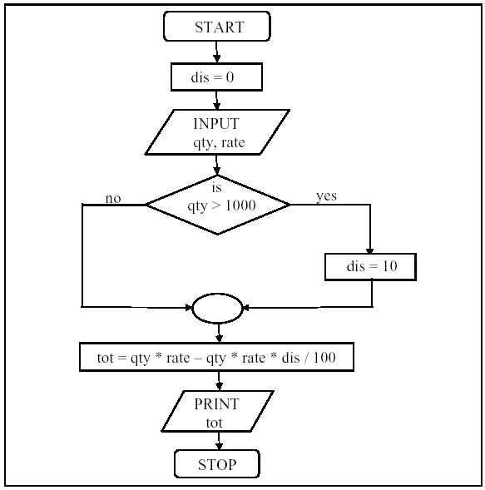

tot = qty*rate – qty*rate*dis/100

Example:
qty = 1010
rate = 10 TK
tot = qty*rate – qty*rate*dis/100
= 1010*10 – 1010*10*(10/100)
= 10100 - 1010

Solution: ifelse-example-1.c

- Write a program that takes an integer value as input and determines whether the number is even or odd. If the value is even then it outputs “The value is even”; otherwise, it outputs “The value is odd”.

Solution: ifelse-example-2.c

- Compute the gross salary of an employee according to the following table:

NOTE: Need to write multiple statements within if else body.

Basic salary | Housing allowance | Medical allowance
Less than 30,000 | 20% | 10%
Greater than or equal to 30,000 | 25% | 15%

Solution: ifelse-example-3.c

- Write a program that takes three integer values as input from keyboard and shows the maximum among the three values. (NOTE: use if statement and relational operators)

Solution: ifelse-example-4.c

- Write a program that takes three integer values as input from keyboard and shows the minimum among the three values. (NOTE: use if statement and relational operators)

Solution: ifelse-example-5.c

- Write a program that takes a floating-point value as input and detects if it is a positive number, a zero or a negative number. NOTE: use nested if-else statements.

Solution: ifelse-example-6.c

- Write the above program using else-if ladder.

Solution: ifelse-example-7.c

- Write a program that takes numerical mark of a course and displays the corresponding letter grade. NOTE: report appropriate error message if the mark is invalid (not within the range [0, 100])

Solution: ifelse-example-8.c

- Write a program that does the basic arithmetic operations on two numbers. First, it asks the user to choose the operation to perform according to the following rule:

  - If user inputs +, then the program performs addition operation.
  - If user inputs -, then the program performs subtraction operation.
  - If user inputs *, then the program performs multiplication operation.
  - If user inputs /, then the program performs division operation.

Secondly, it takes the two numbers an input. Finally, it shows the result of the operation.

Solution: ifelse-example-9.c

- Write a program that takes a year value and checks if it is a leap year or not.

- Input: Any user given int number (year).
- Output: Print “Leap year” or “Not leap year”.
- Algorithm: A year will be a leap year if it is divisible by 4 but not by 100; or it is divisible by 400.
- Note: Use if clause and logical operators to check for a leap year. Use mod “%” operator to find the remainder. If divisible (year), then the remainder is 0.

Solution: ifelse-example-10.c

- Find the absolute value of a number entered through the keyboard. That is if the number entered is negative, the corresponding positive number will be displayed. If the number is positive, it should be displayed as it is.

Solution: ifelse-example-11.c

- Write a program to check whether a triangle is valid or not. The three angles of the triangle are entered through the keyboard. A triangle is valid if the sum of all the three angles is equal to 180 degrees.

Solution: ifelse-example-12.c

- Given the lengths of the three sides of a triangle, determine if the triangle is a right triangle or not. (HINT: use Pythagorean equation c² = a² + b²)

Solution: ifelse-example-13.c

